Portsmith

The Map

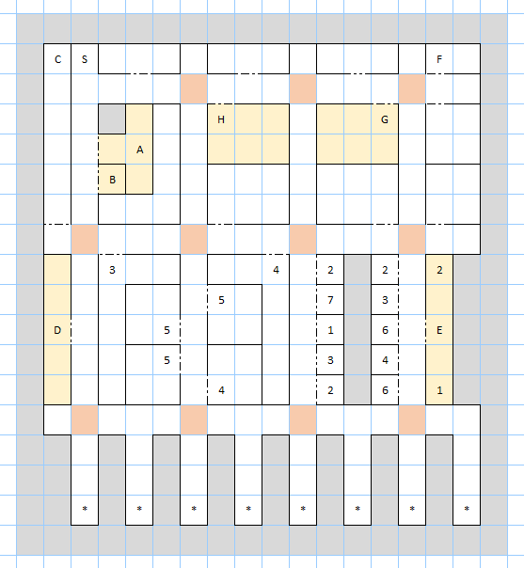

Places of Note
- Inn of Portsmith (Inn)
- Maid Marion's Market (Food)
- Stairs Down (Dungeon)
- Zorelda's Watering Hole (Tavern)
- Temple Succubon (Temple)
- Note: ZAM 12, 2
- B. Smith's Workshop (Shop)
- Amazonia's Training (Trainer)

Encounters
- Minor Demon
- Minor Devil
- Harpy
- Wicked Witch
- Hag
- Lesser Demon
- Lesser Devil
- Random

Other Notes
The orange tiles drain male characters in the party of their health. Most of the encounters are fixed, apart from those in the southern alleys.

