The Town of Erliquin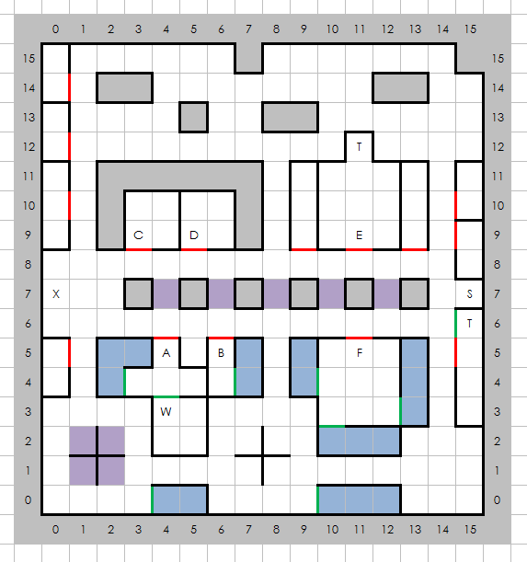

# Places of Note

1. Inn of Erliquin
2. Four Star Foods
3. Current Trends Ironworks
4. Tavern of Tall Tales
5. Superior Training
6. Temple Gauche
7. Stairs Down
8. Town Exit
9. Town Treasure
10. The Wizard Agar