The Wilderness of Erliquin (B-1)
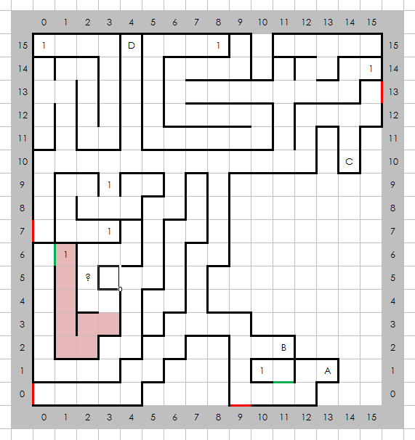

Places of Note
- Entrance to Erliquin
- Entrance to castle Blackridge, East
- Entrance to castle Blackridge, North
- Gates to another world

Encounters
- Random

