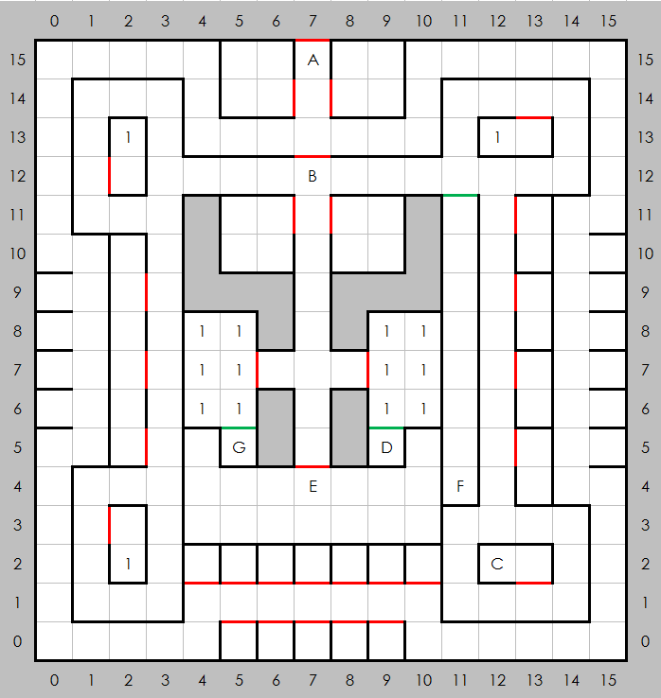
Castle Blackridge, North

Places of Note
- Entrance
- No passage beyond this point without a merchant pass from C-1
- A prisoner
- A note: ATIS-19-31UD54AEUPI1
- Lord Inspector, gives quests
- A slide, takes you to otherwise unreachable area in B-1
- Minor treasure

Encounters
- Random

