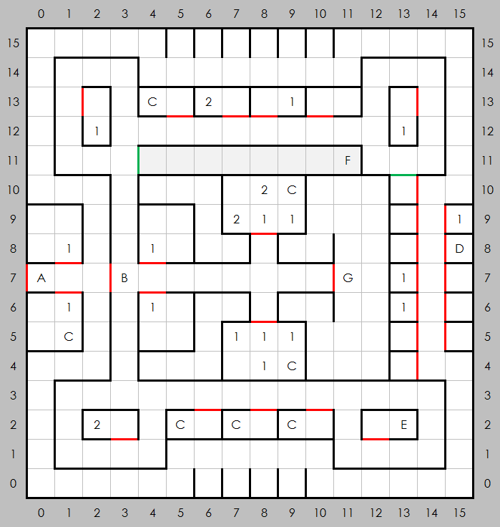
Castle Blackridge, West (B-1)

Places of Note
- Entrance
- No entry without merchant pass from C-1 past this point
- Empty vaults, trigger alarms
- A note on the wall: IACI1;-2;ONU--G,NOT2
- A prisoner
- A slide, takes you to unreachable area of B-1
- Lord Hacker, gives quests

Encounters
- Random
- Random higher level

