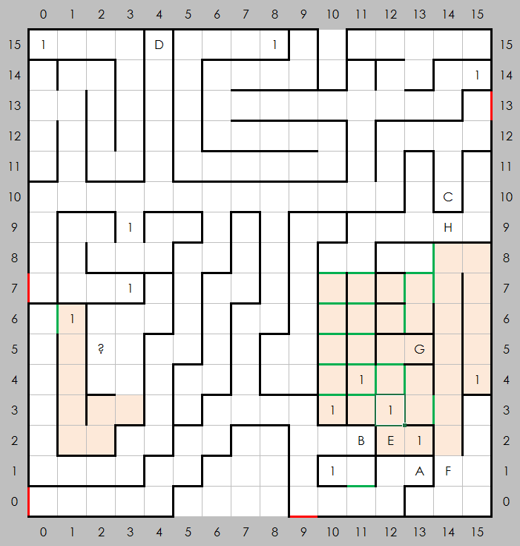
The Wilderness of Erliquin (B-1)

Places of Note
- Entrance to Erliquin
- Entrance to castle Blackridge, East
- Entrance to castle Blackridge, North
- Gates to another world
- This is where the slide from castle Blackridge, West takes you.
- A cave
- A wizard's lair
- This is where the slide from castle Blackridge, North takes you.

Encounters
- Random

Notes
The pink areas are to dangerous to rest in. The area under ? is not fully explored yet.

