The Wilderness of Erliquin (B-1)
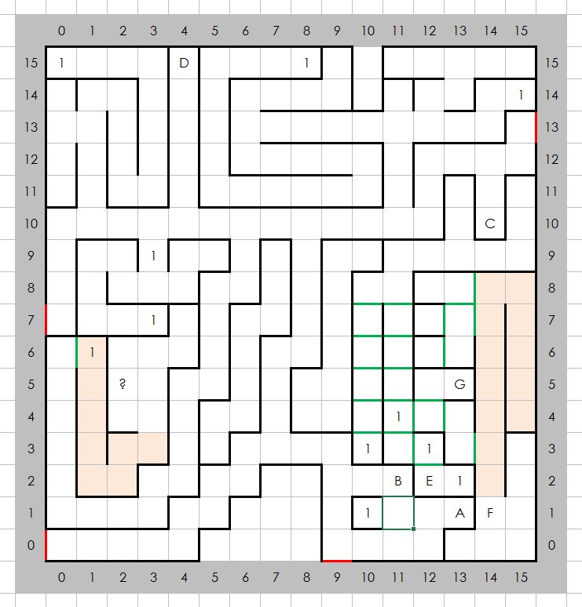

Places of Note
- Entrance to Erliquin  - Entrance to castle Blackridge, East  - Entrance to castle Blackridge, North  - Gates to another world  Encounters  - Random | - This is where the slide from castle Blackridge, West takes you.  - A cave  - A Wizard's Lair  - This is where the slide from castle Blackridge, North takes you.

