Map of Sorpigal

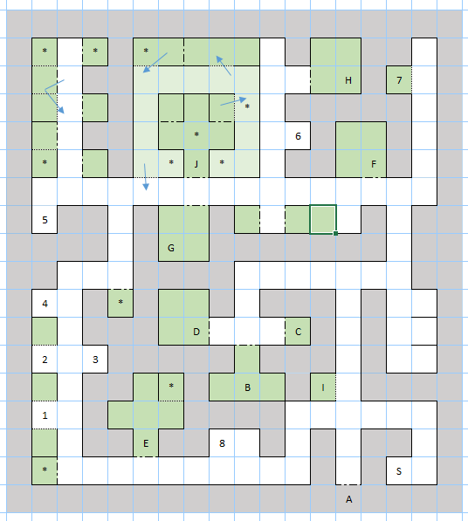

Places
A – Town Gate
B – The Inn of Sorpigal
C – Eulard’s Fine Foods
D – B and B Blacksmiths
E – Temple Moonshadow
F – Otto’s Training
G – Locked room with trap door to dungeon
H – Ye Olde Hogge Tavern
I – Teleporting Leprechaun
J – Jail
* - Possible fixed encounters
S – Stairs down to dungeon

Statues
1 – In memory of a time long ago… Before the days when the towns moved underground, dragons were few and far between.
2 – In honor of Gala… For her brave attempt to work with the savages of The Volcanic Isles
3 – Services rendered, secrets unfold, the Brothers together lead to treasures untold. Five towns you must travel for this quest to unravel.
4 – This beast once roamed The Enchanted Forest and now rules a great fortress there.
5 – Seek the wizard Ranalou in his lair at the Korin Bluffs. Six castles he will send you to, but Doom will be quite tough! Cruelty and kindness measured throughout, judgment day is then sought out.
6 – One by water, one by land, one by air, and one by sand. The Wheel of Luck will favorably pay, the more of these menacing beasts you slay! Although wishes may come true, all the beasts will become anew.
7 – There are many dungeons like me. Find the right pair and you’ll discover the key. The ancient seer Og has lost his sight, the idols will help to end his plight.
8 – In honor of Corak… For his mapping expedition of the land of Varn and rediscovery of the lost town of Dusk.

