The Dungeon below Sorpigal
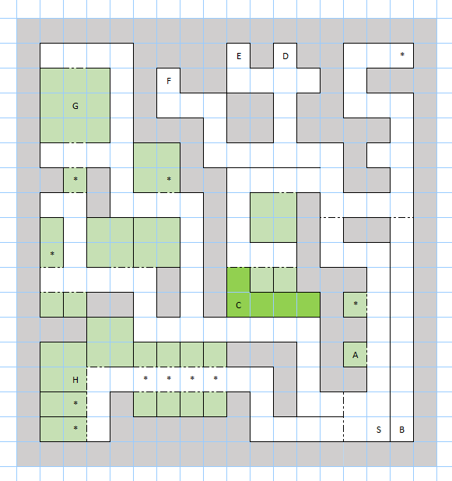

Places of Interest
S – Entrance, Stairs Up.
A – Scrawled on the wall, a message reads: The Jail above has many cells.
B – Portal, one way transport to a cave in the wilderness outside Sorpigal (C-2).
C – A room in constant darkness, with seemingly nothing inside.
D, E, F – Walls with messages saying not to turn around. Walk away backwards to avoid ambush.
G – The Arena. Take part in tough battles.
H – An old man with a quest to take a scroll to the wizard Agar in Erliquin
* – Potential fixed encounters

