The Sorpigal Wilderness
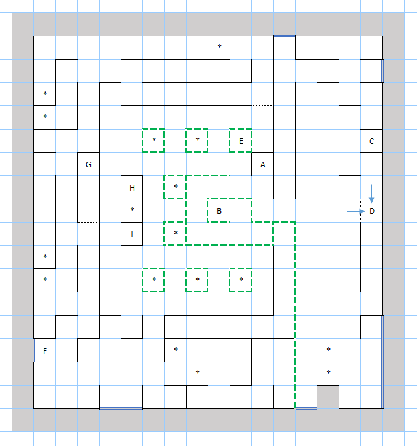

Places of Note
A – The entrance to Sorpigal.
B – A monument which serves as a one-way transport to a random spot in the area.
C – Entrance to a cave, the same cave you can transport to via the portal from the dungeon below Sorpigal.
D – An avalanche triggers here, closing the northern and eastern passage and traping you in this area. You can only go to the easter region once the avalanche is triggered. You cannot go directly back.
E – A gypsy can reveal each character’s „sign“. The sign seems to change after every reload.
F – Statues block the way here, breaking them starts a battle against a group of Caryatid guards. It’s a tough battle, but winnable around levels 4 and 5.
G – An item cache, minor items,
H, I – Fountains you can drink from. I’m not sure what they do.
* – Potential fixed encounters.

Other Notes
The green lines are walls of trees you can pass through. The blue lines are passages to adjanced regions of the world.
Once the dungeon below Sorpigal is cleared, the party should be at sufficient level to deal with the wilderness, though as usual, caution and frequent returns to the inn are advised.

