Cave Near Sorpigal (C-2)

The Map

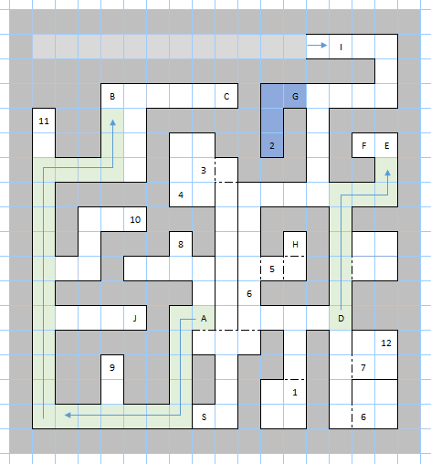

Places of Note
S – Start, Entrance to the Cave.
A – Slide of acid, takes the party to B.
B – This is where the slide at A takes the party. Stepping on the path of the slide does damage and takes the party back to B.
C – Teleporter, transports the party to encounter #2.
D – Slide of acid, takes the party to E.
E – This is where the slide at D takes the party. Stepping on the path of the slide does damage and takes the party back to E.
F – Teleporter, transports the party to encounter #2.
G – This blue area is eternally dark. Torches and the Light spell do not work here.
H – A button here disables the two slides.
I – The corridor of infinite encounters. The party cannot advance past this point. Attempting to advance simply triggers a random encounter.
J – A portal. Takes the party to sector B-3, to the dungeon below the town of Portsmith. This is a one way trip.
1 – Barbarians  2 – Acidic Blobs  3 – Ogres  4 – Cyclops  5 – Caryatid Guard  6 – Giant Spiders | 7 – Militiamen  8 – Centaur  9 – Dinolizards  10 – Wild Boars  11 – Fire Beetles  12 – Druids

Encounters

Other Notes
The green area are the paths of the slides. Slides do damage and take the party in one direction. The only way to get past them is to push the button at location H. Each time the party leaves the dungeon, this button and the slides reset.
The blue area is constantly dark and cannot be lit up.
I couldn’t figure out the corridor of infinite encounters yet.
The main goal of the dungeon is to fight the giant spiders at 6 and the caryatid guards at 5, and then push the button to activate the slides. After that, the rest of the dungeon can be explored.

