The Town of Erliquin

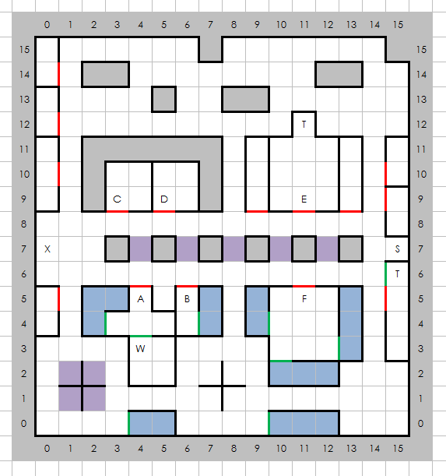

Places of Note
- Inn of Erliquin
- Four Star Foods
- Current Trends Ironworks
- Tavern of Tall Tales
- Superior Training
- Temple Gauche
- Stairs Down
- Town Exit
- Town Treasure
- The Wizard Agar

