Castle Blackridge, West (B-1)
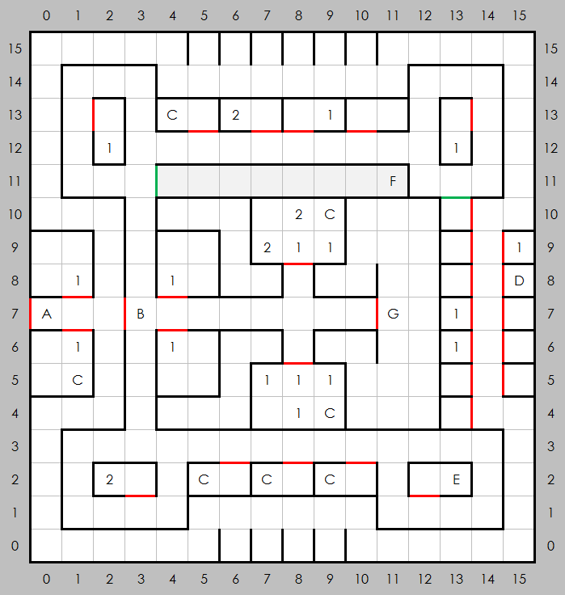
Places of Note  - Entrance  - No entry without merchant pass from C-1 past this point  - Empty vaults, trigger alarms  - A note on the wall: IACI1;-2;ONU--G,NOT2  - A prisoner  - A slide, takes you to unreachable area of B-1  - Lord Hacker, gives quests | Encounters  - Random  - Random higher level

