Wilderness of C-1
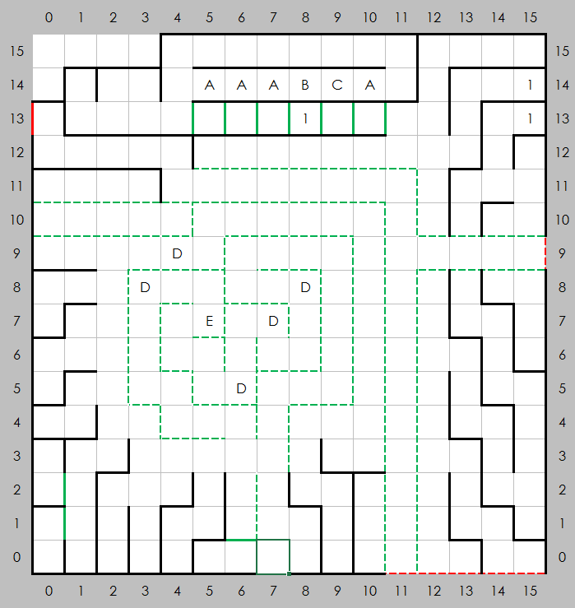

Places of Note
- Poison Fountain
- Might Fountain
- Spell Fountain
- Abandoned merchant wagon, ambush by trolls, ogres, swordsmen, etc.
- Abandoned merchant wagon, contained a merchant's pass. Might be random which one it is.

